What is information System Management

Antti Pikkuaho

What is Information System Management

Fall 2017

Information Processing Sciences

Oulu University of Applied Sciences

# information systems

The modern world is often said to be living in the Information age. There is a lot of information being used and created around the world. This information needs to be stored, categorized, searched and sorted. Every day we create 2.5 quintillion bytes of data and of all the data that exists in the digital world today 90% was made in the last 2 years. (Love C. 2013, date of retrieval 4.1.2018.) The amount of stored information is growing almost exponentially year by year and it’s said that the size of the digital universe will double every two years at least (InsideBigData 2017, date of retrieval 4.1.2018).

So clearly something is needed to manage this huge amount of information. That’s where Information Systems come in. Information systems help us create, store, control, find and access this information. (Love C. 2013, date of retrieval 4.1.2018.)

An Information system is a set of computer-based tools for collecting, storing and processing data. These systems are used by businesses and other organizations to carry out and manage their operations, interact with their customers and suppliers, compete in the marketplace.

(Love C. 2013, date of retrieval 4.1.2018.)  
  
Information systems consist of five components:

* Hardware (Physical devices)
* Software (Tells hardware what to do)
* Data (Info manipulated by the software)
* People (All the people involved)
* Process (Steps to accomplish a goal)

(COTC A.R.C 2014, date of retrieval 4.1.2018)

The use for information systems are wide and varied. For example corporations use information systems to reach their potential customers with targeted advertisements through the internet, to process financial accounts and to manage their workforce. Governments use information systems to provide services cost-efficiently to citizens, to manage the economy and to gather taxes. Digital goods, e-books and software for example, and online services such as e-bay, facebook and other social media platforms are all provided by, and operated using, some kind of an information system. (Love C. 2013, date of retrieval 4.1.2018.)

A typical information system will have somewhere to store the data (Database), a program that will use the data with a user interface where the user can input commands and see results. Information systems are now extremely important in our day to day lives. Having an understanding of them, and the ability to comprehend how to manage them, is vital in our modern day and age. (Love C. 2013, date of retrieval 4.1.2018.)

# Information system management

Our reliance on information systems and the data they have creates a dire need to manage them efficiently. That is why there are many possible education programmes. One example of such an education programme is Haaga-Helia’s degree programme in information systems management in Helsinki (Haaga Helia 2018, date of retrieval 4.1.2018). These programmes are designed to get students into the field of information system management. When they finish these studies they may continue on the career path of an information system manager for example.

(Study.com 2018a, date of retrieval 4.1.2018.)

Information system managers oversee tasks that are related to information systems. Examples of such tasks include directing or coordinating research and overseeing network security or internet operations. “Information system managers are responsible for coordinating the computer-related actions of the company.” Due to their responsibilities; they are expected to have lots of experience working with information technology. (Study.com 2018b, date of retrieval 4.1.2018.)

Information system managers are typically employed by financial organisations, IT companies, management consultancy firms, software companies, universities, hospitals, government and online retailers. Basically any organisation that makes use of computers may employ an information systems manager. (TARGETjobs 2018, date of retrieval 4.1.2018.)

Typical tasks for an information system manager, and thus can be concluded to be what information system management entails, are:

* Managing a team of staff that are related to the ICT-field, for example programmers and analysts
* Evaluation of systems
* Consulting users of their needs to ensure that user and project needs are met
* Selecting and purchasing hardware and software
* Managing budgets relating to IT
* Ensuring licensing laws are followed
* Taking care of security, integrity and backup procedures
* Handling and scheduling of upgrades
* Providing user training, support, advice and feedback
* Testing and modifying systems
* Managing secure network access for remote users
* Designing maintenance procedures

(TARGETjobs 2018, date of retrieval 4.1.2018.)

# Different types of information systems

The different types of information systems are:

* Executive Support Systems (ESS)
* Management Information Systems (MIS)
* Decision Support Systems (DSS)
* Knowledge Managemen Systems (KMS)
* Transaction Processing Systems (TPS)
* Office Automation Systems (OAS)

These systems are associated with groups of people within an organization. These different types of systems are often illustrated with a pyramid model (Figure 1). Several versions of this model exist, but this four level pyramid model is the most common version because it includes the most common hierarchies in use at an organization. The purpose of this model is to illustrate the systems based on the groups of people using those systems. (Visser 2011, 20.)

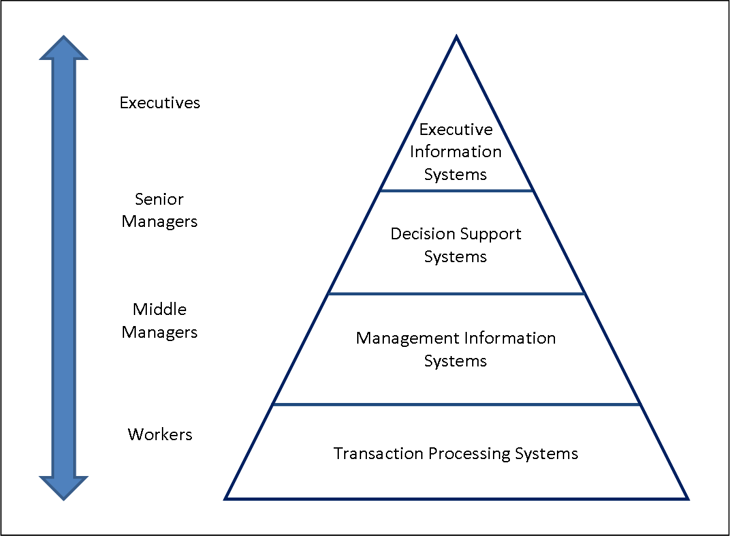FIGURE 1. Four Level Pyramid Model of the types of IS systems, based on organizational hierarchy (Euromed Marseille School of Management 2010, date of retrieval 4.1.2018).

Since these four are the most common ones it’s good to know their differences and characteristics.

## Transaction Processing Systems

Transaction Processing Systems are at the bottom of the pyramid for a reason. They are simple operational-level data processing systems. They are usually operated by workers or staff, the workers provide the data required to support the management of operations. This data is usually from low-level activities and basic transactions. (Euromed Marseille School of Management 2010, date of retrieval 4.1.2018.)

## Management Information Systems

Many of the different types of Information systems from commercial organizations are called Management Information Systems for historical reasons. In the Figure 1 above, the pyramid model, they are management-level systems used by middle managers. They are used to evaluate an organizations performance. Some other examples include sales management-, inventory control- and budgeting systems. (Euromed Marseille School of Management 2010, date of retrieval 4.1.2018.)

## Decision Support Systems

The Decision Support System is a knowledge based system that is used by senior managers. It’s for creating knowledge. These systems are used to analyze existing information and can be used by managers to examine potential effects of their decisions. They offer access to databases and analytical tools as well as supporting exchange of information within the organization. (Euromed Marseille School of Management 2010, date of retrieval 4.1.2018.)

## Executive Information Systems

This information system is a strategic-level information system. It’s on top of the pyramid because it helps executives and senior managers analyze the operational environment of the organization, identifies trends and facilitate planning for future courses of action. The system is designed to be used by executives and easily tailored to his or her preferences. (Euromed Marseille School of Management 2010, date of retrieval 4.1.2018.)

References

COTC A.R.C. 2014. The 5 Components of an Information System. Cited 4.1.2018, https://www.youtube.com/watch?v=XlcolUHMnh0

Euromed Marseille School of Management. World Med MBA Program - Information Systems and Strategy. Types of Information System and the Classic Pyramid Model. Cited 4.1.2018, http://www.chris-kimble.com/Courses/World_Med_MBA/Types-of-Information-System.html

Haaga-Helia. 2018. Degree Programme in Information Systems Management. Cited 4.1.2018 http://www.haaga-helia.fi/en/education/master-degree-programmes/degree-programme-information-systems-management

InsideBigData. 2017. The Exponential Growth of Data. Cited 4.1.2018, https://insidebigdata.com/2017/02/16/the-exponential-growth-of-data/

Love, C. 2013, What is an Information System. Cited 4.1.2018, https://www.youtube.com/watch?v=Qujsd4vkqFI

Study.com. 2018a. Career Info for a Degree in Information Systems Management. Cited 4.1.2018, https://study.com/articles/Career_Information_for_a_Degree_or_Certification_in_Information_Systems_Management.html

Study.com. 2018b. Information System Management. Cited 4.1.2018, https://study.com/directory/category/Business/Information_System_Management.html

TARGETjobs. 2018. Information Systems Manager: Job Description. Cited 4.1.2018, https://targetjobs.co.uk/careers-advice/job-descriptions/279831-information-systems-manager-job-description

Visser, M. 2011. Towards developing an evaluation tool for business management information systems’ success at public further education and training (FET) colleges in South Africa. Cited 4.1.2018, http://uir.unisa.ac.za/bitstream/handle/10500/5789/thesis_visser_m.pdf?...1